- Do not edit/delete any heading or section with red text.
- Type /paste you answers in relevant sections (below Final Answer (in all questions , Approach (wherever required ) and Charts & tables (wherever required)) of the solution
- Link to submission guidelines
- Please note that submission not following the guidelines will not be accepted

OBJECTIVE QUESTIONS

Question 1: What is the total no. of tables present in the data?

Solution:

Final Answer (if any):
1 table is present in the dataset.

Approach (if any):
The dataset was examined by reviewing the workbook structure and data source. The provided data consists of a single worksheet containing all consultation records and attributes. No additional relational tables were provided in the source dataset.

Charts & Tables (if any):
No tables and Charts have been created.

Question 2: What is the total no. of attributes present in the data?

Solution:

Final Answer (if any):
35 attributes are present in the original dataset.

Approach (if any):
The total number of attributes was determined by counting all columns present in the original dataset before any data preparation or helper columns were added. The dataset contains 35 original attributes describing consultation records, customer details, guru details, revenue information, status information, ratings, and timestamps.

Charts & Tables (if any):
No charts and tables have been created.

Question 3: The data consists of some inconsistent and missing values so ensure that the data used for further analysis is cleaned.

Solution:

Final Answer (if any):
The dataset was cleaned by checking for duplicates, investigating missing values, standardizing text fields, and creating helper columns for analysis. No duplicate records were found. Missing values were retained where they represented valid business scenarios rather than data-quality issues.

Approach (if any):
- Checked for duplicate records and found no duplicate rows.
- Performed missing value analysis using COUNTBLANK().
- 18 columns contained missing values and investigated the reason for the missing data.
- Determined that many missing values were expected because chat consultations do not contain call-related information and call consultations do not contain chat-related information.
- Standardized text values by:
- Replacing multiple spaces with a single space using Find & Replace.
- Correcting inconsistent capitalization in guru names.
- Correcting verified text inconsistencies and spelling variations.
6. Created helper columns (Date, Month, Month Number, Year, and Day Name) from the createdAt field to support analysis and dashboard development.

Charts & Tables (if any):
No charts and tables were created.

Question 4: What is the change in daily call volume day by day and also find the average daily call volume.

Solution:

Final Answer (if any):
Average daily call volume = 245.97calls/day.
Volume fluctuates significantly day to day (swings from -122 to +150).
Highest day: 10-Dec-2023 (430 calls).
Lowest day: 3-Jan-2024 (107 calls, partial data - only 3 days of January exist).

Approach (if any):
- Pivot Table on data sheet: Filter: consultationType = Call → Rows: createdAT grouped by Days+year → Values: Count of CallSid.
- Added a helper column (=C3-C2) beside the pivot to calculate day-over-day change. =AVERAGE(), =MAX(), =MIN() applied to the Count column for summary stats.
Charts & Tables (if any):

Daily call volume chart was created for showing day to day fluctuations in call volumes.

Question 5: Which months experienced the highest and lowest call volumes?

Solution:

Final Answer (if any):
December 2023 = 8,090 calls (highest). January 2024 = 418 calls (lowest), but note January only has 3 days of data, so it's not a fair "low month," just an incomplete one.

Approach (if any):
Pivot table with dates grouped by Month, Count of CallSid, filtered to Call.

Charts & Tables (if any):

A Pivot Table and column chart showing the total consultation volume for each month.

Question 6: What is the total operational cost for that month?

Solution:

Final Answer (if any):
- Dec 2023 - Astrologer Earnings: ₹93,786.16 | Net Amount: ₹2,02,214.63 | Gross Amount: ₹2,02,239.21
Jan 2024 - Astrologer Earnings: ₹5,360.41 | Net Amount: ₹11,772.69 | Gross Amount: ₹11,826.69

Approach (if any):
Pivot table, Rows: Month, Values: Sum of astrologersEarnings/netAmount/amount.

Charts & Tables (if any):

Stacked column chart comparing astrologer earnings, net amount, and gross amount by month.

Question 7: What is the average number of calls handled per agent per day?

Solution:

Final Answer (if any):
Formula: =Average of number of calls/Total Number of days.
= 2.22 calls per agent per day.

Approach (if any):
Calculate the average number of calls using the Average() function and divide it by total number of days(34) to find the average number of calls handled per agent per day.

Charts & Tables (if any):
No Tables and charts were created.

Question 8: How many repeat callers are there, and what percentage of total calls do they represent?

Solution:

Final Answer (if any):
1,275 repeat callers out of 3,628 unique callers (35.14% of unique callers are repeat callers).
Repeat calls represent 56.62% of total call volume.

Approach (if any):
Repeat % = (valid calls − unique callers) ÷ valid calls

Pivot on uid, helper column to flag repeats, SUM/COUNT formulas for percentages.

Charts & Tables (if any):

Pie chart showing the split between repeat and one-time callers by call volume share.

Question 9: What are the total sales generated by the call centre for each product category?

Solution:

Final Answer (if any):
The dataset does not contain a product category field. Using website as the closest available proxy for sales channel: App = ₹1,25,216.79, Gurucool = ₹43,225.25. App accounts for roughly 74% of total Call revenue.

Approach (if any):
No dedicated "category" column exists in this dataset, so website (App vs Gurucool) was used as the nearest categorical substitute, since it's the only field with meaningful variation relevant to sales. Built using a PivotTable: Rows = website, Values = Sum of netAmount, Filter = consultationType = Call.

Charts & Tables (if any):
Table / Chart Name: Sales by Channel (Website)
Description: Pie chart showing the split of total call revenue (amount) between App and Gurucool.

Question 10: How many calls were made for each user ID and guru ID?

Solution:

Final Answer (if any):
3,628 distinct users placed calls; 111 distinct gurus handled calls. Top user: uid 33832 with 113 calls. Top guru: gid 256 = Astro Shalini with 1,060 calls

Approach (if any):
Two separate pivot tables, the full breakdown is a list, not a single summary number, so the screenshot of some of the cells is given below.

Charts & Tables (if any):
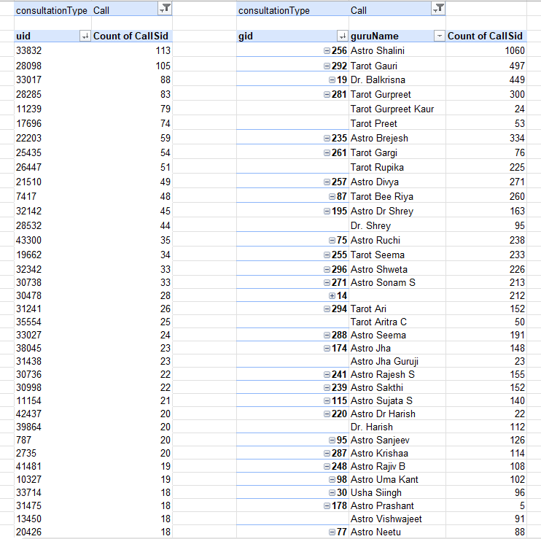

Two Pivot Tables showing the number of consultations made by each User ID and handled by each Guru ID.

Question 11: What is the correlation between call duration and customer satisfaction?

Solution:

Final Answer (if any):
0.007793054 - essentially zero. Call duration has no meaningful relationship with customer satisfaction rating.

Approach (if any):
CORREL() function applied to userOnCallDuration and rating, filtered to completed calls only.

Charts & Tables (if any):
No charts were created.

Question 12: Which guru has the highest and lowest customer satisfaction scores?

Solution:

Final Answer (if any):
Highest -Astro Pujaa Rai, average rating 7.50 and Tarot Mystical, average rating 7.50. Both Gurus have the highest satisfaction score.
Lowest -Tarot Rittika, average rating 0 has the lowest customer satisfaction score

Approach (if any):
Created a Pivot table with Rows = GuruName with values as Average of Rating.

Charts & Tables (if any):
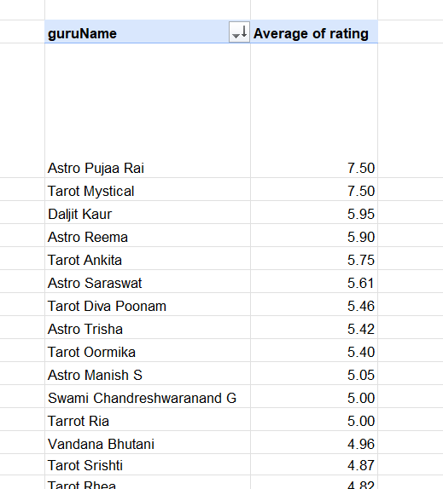

Question 13: What is the average customer satisfaction score by month?

Solution:

Final Answer (if any):
Dec 2023 = 2.95, Jan 2024 = 2.68 – they are almost the consistent, no meaningful month-to-month difference in satisfaction.

Approach (if any):
Pivot table, Rows: Month, Values: Average of rating, filtered to completed Call records.

Charts & Tables (if any):

Table/Chart Name: Monthly Avg Satisfaction
Description: Column chart comparing average rating across Dec 2023 and Jan 2024.

Question 14: How many categorical columns are there in the data? [Search about categorical and continuous data, and try to answer this question]

Solution:

Final Answer (if any):

Categorical columns = 16

chatStatus, guruName, consultationType, website, refundStatus, isWhiteListUser, queue, freeCall, freeChat, callChannel, callIvrType, callStatus, astrologerCallStatus, region, userCallStatus, rating.

Continuous Columns = 8
- chatSeconds
- timeDuration
- amount
- astrologerOnCallDuration
- astrologersEarnings
- netAmount
- userOnCallDuration
- rating

Approach (if any):
Counted the number of Categorical and Continuous columns.

Charts & Tables (if any):
No Tables or Charts were created.

SUBJECTIVE QUESTIONS

Question 1: Should the investment be used to hire more agents, improve training programs, or upgrade call center technology?

Solution:

Approach:
Compared three charts side by side, one per investment option.
(1) call outcome breakdown - tests the "technology" theory,
(2) agent workload distribution - tests the "hiring" theory,
(3) guru rating spread tests the "training" theory.
Whichever chart shows the biggest, most fixable gap points to where the ₹ should go.

Charts & Tables:

Table/Chart Name: Call Outcome Breakdown (Technology angle)
Description: Pie/donut chart of callStatus (completed/no-answer/busy/failed/incomplete). Shows only 41.25% of calls actually connect.

Table/Chart Name: Agent Workload Distribution (Hiring angle)
Description: Column chart of calls handled per guruName, sorted descending. Shows massive skew, top agent Astro Shalini handled 1,060 calls, 25th percentile agents handled only 6.

Table/Chart Name: Guru Satisfaction Leaderboard (Training angle)
Description: Bar chart, top 5 vs bottom 5 gurus by average rating

Option | Quantified impact
Technology | If even 10% of the 4,913 non-completed valid calls converted at the average completed-call value (₹48.82 net), that's ≈₹23,987 recovered in this 34-day window alone, scales to lakhs annually
Training | Rating and revenue barely relate at all (correlation = 0.011) so training has no clear, quantifiable revenue payoff in this data, unlike technology

Insights:
58.75% of calls never connect at all (busy/no-answer/failed/incomplete combined) that's the single biggest leak in the funnel, larger than the workload imbalance or the training gap.
The workload imbalance (existing agents ranging from 1 call to 1,060 calls) suggests there's already unused capacity among current agents before you'd need to hire net-new ones.
The training-driven rating gap (2.90 to 4.10) is real but comparatively small next to the 59% connection failure rate.

Recommendations:
According to the above table,
Prioritize technology investment first, since fixing the connection rate has the largest and most direct revenue impact.
Follow with workload redistribution among existing agents before considering hiring more agents.
Treat training as a lower-priority, longer-term lever since its impact ceiling is smaller than the other two.

Question 2: What are the potential risks of each investment option (hiring, training, technology upgrades), and how can they be mitigated?

Name the chart/spreadsheet function you will use for solving the problem.

Solution:

Approach:
- For each option (hiring, training, tech), the risk was validated with a direct formula against the raw data and reading a pivot summary, then paired with a mitigation.
- Hiring risk validated with =PERCENTILE(CallCount_range, 0.25) on the agent workload data returns 6.
- Tech risk validated with callStatus and count of callSid Pivot, the calls which were not completed returns 58.75%.
- Training risk validated with =CORREL(timeDuration_range, rating_range) on completed calls only calculated earlier returns 0.007984932.

Charts & Tables:

Table/Chart Name: Agent Workload Distribution
Description: Demonstrates the hiring risk (adding headcount without fixing distribution just adds more idle capacity).

Insights:
- Hiring risk: with 25th-percentile agents handling only 6 calls in 34 days ,adding more agents risks diluting workload further rather than solving a capacity shortage.
- Tech risk: 58.75% of valid calls fail to complete. Any technology spend that doesn't address the busy/no-answer/failed causes won't move this number.
- Training risk: call duration has essentially zero correlation with rating, so it's unclear training will move satisfaction much if the real driver is something not captured in this dataset.

Recommendations:
- Mitigate hiring risk by redistributing the workload among existing agents before hiring new ones.
- Mitigate tech risk by integrating a new system on the busiest hour window (6–11 AM) first, where failure volume is highest, before a full rollout.
- Mitigate training risk by collecting an additional data point (e.g. a post-call survey asking why the customer rated as they did) before committing budget.

Question 3: How does AstroSage's call center performance compare to AstroGuru's average call volume, customer satisfaction, and agent performance?

Will you use any aggregation function or a visualization here to solve the problem?

Solution:

Approach:
There's no AstroGuru data in this dataset, so a direct comparison isn't possible without making numbers up. What we can do is lay out AstroSage's own numbers clearly so they're ready to compare against AstroGuru if that data ever becomes available.

Charts & Tables:
- Table / Chart Name:
Aggregation Functions
- SUM
- COUNT
- AVERAGE
- Pivot Tables
Visualizations
- Daily Consultation Volume & Average Rating
- Revenue Distribution by Consultation Type
- Top 10 Gurus by Consultation Volume
- Top 10 Gurus by Average Rating
- Description:
- Shows daily consultation demand along with changes in customer ratings, helping evaluate operational consistency.
- Displays the gurus handling the highest number of consultations to evaluate workload and productivity.
- Identifies the highest-rated gurus based on customer feedback to measure service quality.
- Shows the contribution of each consultation type toward total revenue.

Insights:
AstroSage handled 28,027 consultations total. Calls bring in close to 79% of total revenue, making them the main moneymaker. Average customer rating, once you exclude the 0s from failed/no-answer calls, comes out to 3.96, meaning there's room to improve but it's not a crisis.

Recommendations:
Keep these benchmark numbers documented so a real AstroGuru comparison can happen later. In the meantime, focus on the same fixes as everywhere else, balance workload and train lower-rated gurus.

Question 4: How can the call center improve its handling of peak call periods to ensure high customer satisfaction?

Mention the functionality you will use for giving the suggestions, will it be any aggregated function or a visualization?

Solution:

Approach:
A pivot table was used to group calls by hour of the day to find out when the call centre is busiest, and then satisfaction ratings during those busy hours were compared against the rest of the day. This needed both an aggregation (count of calls by hour, average rating by hour) and a visualization to actually see the pattern clearly.

Charts & Tables:
Table / Chart Name: Hourly Volume vs Satisfaction
Description: A Combo chart of line chart showing call volume across each hour of the day, filtered to call data only and A column chart comparing average rating during the busiest hours against the rest of the day.

Insights:
Volume peaks sharply around mid-morning and stays high through the late morning.
The rating line stays fairly steady across the busy hours, which suggests the team is currently managing quality okay even when it's busiest, so the bigger issue is getting more calls to connect in the first place rather than a quality drop during the rush.

Recommendations:
Shift more agents to start earlier so staffing is already at full strength before volume ramps up, rather than catching up once the rush has started.

Question 5: Based on historical data, what strategic initiatives should be prioritized to improve efficiency and customer satisfaction?

Solution:

Approach:
Historical consultation data was analysed using Pivot Tables, KPI cards, and dashboard visualizations to evaluate consultation trends, customer ratings, workload distribution, revenue contribution, and consultation outcomes. These analyses helped identify operational bottlenecks and prioritize improvement initiatives.
All earlier findings were ranked by size and fixability, now backed by two additional comparisons: revenue by channel type, and where call volume concentrates by platform.

Charts & Tables:
-Table/Chart Name: Revenue Generated by Consultation Type (Net Amount)
-Description: Column chart comparing total netAmount between Call (₹1,68,442.04) and Chat (₹45,494.68).

-Table/Chart Name: Website Distribution
-Description: Pie chart showing Call volume split, App (7,652 calls) vs Gurucool (711 calls).

-Table / Chart Name:
Metric | Call | Chat
Completed avg rating | 3.49 (scale 0–5) | 7.01 (scale 0–8)
Normalized (% of scale) | 69.8% | 87.6%

Platform (Call only) | Avg rating | Completed calls
App | 3.49 | 3,124
Gurucool | 3.52 | 326

-Description: Not Applicable

Insights:
Call generates roughly 3.7x more net revenue than Chat despite having less than half the volume, confirming Call is the higher-value channel worth prioritizing for the technology fix.
Nearly 91% of Call volume runs through the App platform, meaning any technology or reliability investment should focus there first, since it affects the vast majority of interactions.

Recommendations:
Prioritize fixing Call's connection failure rate first, since it's both the highest-revenue channel and the platform carrying 91% of volume. Treat Gurucool as a secondary channel to monitor, not a priority investment area, given its much smaller share.

Question 6: What can be the key factors contributing to high customer satisfaction scores, and how can these be leveraged to improve overall performance?

What is the basis for the suggestions? And mention how you decided if the satisfaction score affects the ratings.

Solution:

Approach:
Since call duration showed no relationship with rating (0.008), two more angles were tested: how ratings are distributed across users and across gurus, and whether platform or consultation type explains anything duration doesn't.

Charts & Tables:
-Table / Chart Name: Duration vs Rating Scatter
-Description: A scatter chart plotting call duration against rating for completed calls, used to visually confirm whether there's any relationship between the two.

Table/Chart Name: Rating-wise User Distribution
Description: Column chart showing how many distinct users gave each rating

Table/Chart Name: Rating-wise Guru Distribution
Description: Column chart showing how many distinct gurus received each rating

Table/Chart Name: Platform & Channel Rating Comparison
Description: Small table — Call avg rating 3.49 (69.8% of scale) vs Chat 7.01 (87.6% of scale); App avg 3.49 vs Gurucool 3.52 within Call.
Metric | Call | Chat
Completed avg rating | 3.49 (scale 0–5) | 7.01 (scale 0–8)
Normalized (% of scale) | 69.8% | 87.6%

Platform (Call only) | Avg rating | Completed calls
App | 3.49 | 3,124
Gurucool | 3.52 | 326

Insights:
Ratings are almost evenly spread across the 2–5 range for both users and gurus, there's no skew toward high or low ratings, meaning satisfaction isn't concentrated among a few gurus or driven by a few unhappy customers, it's broadly distributed. Platform (App vs Gurucool) makes almost no difference either (3.49 vs 3.52), essentially the same. Combined with the near-zero duration correlation, this dataset doesn't contain a strong quantitative driver of satisfaction at all.

Recommendations:
Since nothing measurable in this dataset explains the rating spread, don't invest based on a guessed driving factor.

Question 7: How should the call center balance the workload among agents to ensure optimal performance and avoid burnout?

Mention your approach and spreadsheet function for the answer.

Solution:

Approach:
Reused the Agent Workload Pareto chart, and added average call duration per agent (not just call count) to check whether the busiest agents are also spending more time per call, which compounds the imbalance.

Charts & Tables:
-Table / Chart Name: Agent Workload Distribution
-Description: A column chart of calls handled per agent, sorted from highest to lowest, showing just how wide the gap is between the busiest and quietest agents.

-Table/Chart Name: Top 10 Gurus by Count/Rating
-Description: Count of CallSid alongside Average ratingfor the 10 busiest gurus.

-Table/Chart Name: Average Call Duration by Agent
-Description: Table showing top agents' call count next to their average duration, e.g., Astro Shalini: 1,060 calls, avg 142 sec; Tarot Gauri: 497 calls, avg 91 sec; Dr Balkrisna: 309 calls, avg 169 sec.

Insights:
Astro Shalini doesn't just handle the most calls (1,060), she also spends more time per call (142 sec) than several less-busy agents like Tarot Gauri (91 sec), meaning her total time-on-calls burden is even more disproportionate than raw call count alone suggests.

Recommendations:
Base workload caps on total time-on-calls (calls × average duration), not just raw call count, since that better reflects actual workload burden. Route new calls toward agents with both low call counts and low average duration first.

Question 8: What new technologies or tools could be implemented to enhance call center operations and customer service?

Solution:

Approach:
Each type of call failure was looked at separately (busy, no answer, failed, incomplete) so that the technology suggestion could match the actual problem instead of being a generic recommendation.
The same call outcome chart from Question 1 was used here as the evidence base.

Charts & Tables:
-Table / Chart Name: Call Outcome Breakdown
-Description: Same donut or pie chart as before, showing the breakdown of completed, busy, no answer, failed, and incomplete calls.

Insights:
No answer is the single biggest reason calls fail, even bigger than busy or failed on their own. This points to agents simply not being reachable at the moment a customer calls in, rather than the system being overloaded or broken.

Recommendations:
- For no answer calls, an automatic callback or predictive dialing system would help catch customers who couldn't get through the first time.
- For busy calls, a smarter queuing system that routes to whichever agent is actually free would help.
- For failed and incomplete calls, it's worth checking the phone network or carrier side of things, since that's less likely to be an agent issue and more likely a system reliability issue.

Question 9: What metrics should be included in the final dashboard to comprehensively view call center performance and guide investment decisions?

Solution:

Approach:
- The goal was to pick one clear metric per major decision area (volume, revenue, quality, and operations) rather than listing everything already calculated, so the dashboard stays readable at a glance.
- Used netAmount and Call counts throughout use CallSid as the identifier, since it reflects genuine call attempts rather than raw row count.

Charts & Tables:
Table / Chart Name: None, this is a list of recommended metrics rather than a chart.
Description: Not applicable.

Insights:
A dashboard with too many numbers on it stops being useful, since no one can act on all of them at once. The metrics that matter most are the ones that map directly to a decision someone would actually make.

Recommendations:
The dashboard should include: daily and monthly call volume (Count of CallSid), overall completion rate (callStatus), total revenue by channel (Sum of netAmount, average satisfaction on completed calls only (scale-normalized), how evenly workload is spread among agents, repeat caller and busiest hours of the day.

Question 10: How would you allocate a 1 crore rupee investment to optimize operational efficiency, enhance customer satisfaction, and boost profitability, and what analysis-based recommendations would you offer to support this?

[you have to give bullet pointers to answer this question]

Solution:

Approach:
The one crore was split based on how big each problem is, rather than splitting it evenly across every area. The biggest chunk went to the issue that showed up as the largest and most fixable across all the earlier questions.

Charts & Tables:
- Table / Chart Name:
- Daily Consultation Volume & Average Rating
- Revenue Distribution by Consultation Type
- Call vs Chat Status Comparison
- Top 10 Gurus by Consultation Volume
- Consultation Status by Day of Week
- Top 10 Gurus by Average Rating

Insights:
The connection failure problem, at almost 60 percent of calls, is clearly the largest and most fixable issue in the whole dataset, so it makes sense for it to receive the biggest share of the budget.

Recommendations:
- About 45 lakhs should go toward call routing and telephony technology, since fixing how calls connect addresses the single biggest leak in revenue.
- About 20 lakhs should go toward a workload rebalancing and scheduling system, given how unevenly calls are currently spread among agents.
- About 15 lakhs should go toward a guru training program, focused specifically on closing the gap between the highest and lowest rated gurus, backed by a proper quality review process.
- About 10 lakhs should go toward strengthening the smaller revenue channel, since most of the current revenue is concentrated in just one platform.
- The remaining 10 lakh should go toward cleaning up the data itself, fixing the mismatched rating scales between Call and Chat and correcting how ratings get logged on calls that never even connected, so future decisions are based on numbers that can actually be trusted.

